FOR IMMEDIATE RELEASE FOR INFORMATION:
June 25, 2019 William Raynard
Public Information officer
978-774-3281
wraynard@essexsheriffma.org

ESSEX COUNTY SHERIFF’S DEPARTMENT GRADUATES 20 CORRECTIONAL OFFICERS FROM BASIC TRAINING ACADEMY
Haverhill, Massachusetts, June 21, 2019… Sheriff Kevin F. Coppinger administered the oath to 20 new Correctional Officers of the Essex County Sheriff’s Department (ECSD) at the Basic Training Academy graduation ceremony held at Northern Essex Community College (NECC) on June 21. The rigorous, 12-week Basic Training Academy on the campus of NECC is the final phase of the process to become a Correctional Officer. The successful graduates, who come from communities throughout Essex County, will now be assigned full-time positions at ECSD run facilities.
“Comprehensive training is the key to excellence and effectiveness in corrections at every level. We have designed a very demanding training program for recruits to become proficient in many critical areas. Their training will continue throughout their work at the Sheriff’s Department as we are committed to building and maintaining a strong, professional team. We look forward to having our new Correctional Officers become an important part of that team,” said Sheriff Coppinger.
In addressing the graduating class, Sheriff Coppinger said, “My heartfelt congratulations go out to each and every one of you! Your hard work, diligence and commitment have brought you to this day and you should be proud. Graduation is a time to celebrate, so enjoy! Tomorrow the work begins. Remember those words we talked about 12 weeks ago-Honesty, Integrity and Respect. Live by those words and you will achieve greater success! Welcome to the Essex County Sheriff’s Department!”
NECC Executive Director George Moriarty attended the ceremony and spoke about the mutually beneficial partnership between the ECSD and NECC to provide a location for ECSD’s Basic Training Academy. A large percentage of law enforcement professionals receive their career related education from community colleges. NECC also offers courses for preparation and/or advancement in corrections careers.
Many proud family and friends of the graduates attended the ceremony. A memorable moment for each new Corrections Officer was when their hard-earned badge was pinned on their new uniform for the first time by a special person in their life.
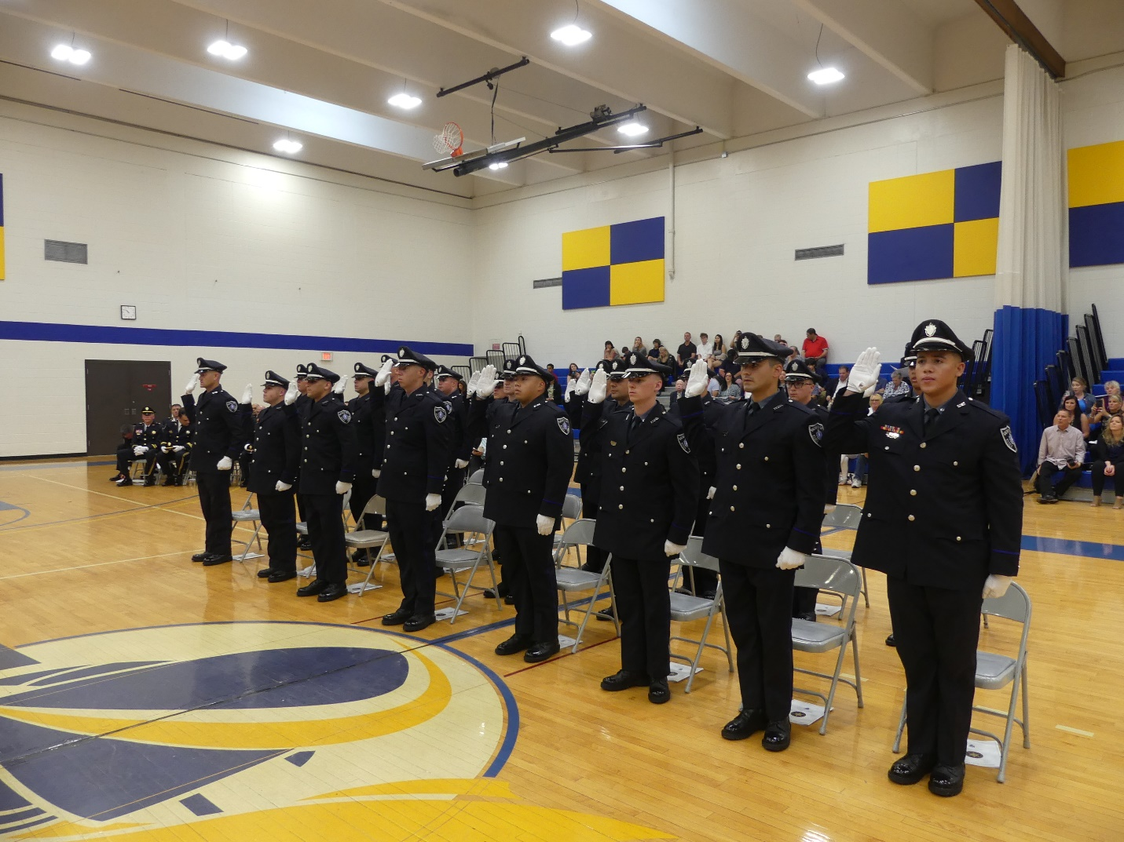
The new Correctional Officers are: Robert Burrell, Christian Calix, John Comerford, Brian Dettorre, Kyle Houghton, Adrian Inoa, Anferne Jimenez, Christopher Jodoin, Shawn Kavanaugh, Keenan Kealey, Erik Laflamme, Terrance Lane, Alexander Nirgianakis, William Panzini, Jacob Roy, Mark Scribner, Jake Skusevich, Blake Ward, James Whitcher, Raymond Wilkins
####

